Comparative Backtesting of Value-at-Risk Methodologies

James Beall
American Public University System
ANLY699: Analytics Project
Dr. Pomponio
October 18, 2026

Comparative Backtesting of Value-at-Risk Methodologies
Introduction
The Rise of Value at Risk
Value at Risk (VaR) became the industry standard for estimating the expected loss of a portfolio over a specific time horizon at a given confidence level (Jorion, 2006; Linsmeier & Pearson, 2000) in response to the inadequacy of legacy risk metrics that failed and resulted in institutional catastrophe during crises including Barings Bank, Orange County, and Metallgesellschaft (Crouhy et al., 2014; Jorion, 2006). Its ubiquity across institutional risk desks stems from its ability to condense complex portfolio risk portfolios into a single, intuitive summary statistic. For example, “there is a 95% confidence level that a portfolio loss will not exceed the VaR threshold amount in a 30-day period (or a 5% probability of exceeding the VaR threshold)”. Historically, risk management frameworks’ underlying VaR has relied on stochastic calculus, specifically Geometric Brownian Motion (GBM), which assumes that asset returns are normally distributed, memoryless, multiplicative, and governed by constant volatility (Peng & Simon, 2024). This paper explores how alternative VaR calculations perform in simulated markets that experience significant shocks that mimic financial crises.
Vocabulary and Structural Failures
To properly evaluate market risk, foundational terms used throughout this paper must be established. Leptokurtosis (fat tails) describes return distributions that exhibit significantly higher probabilities of extreme outcomes than a normal distribution (Cont, 2001). Heteroskedasticity refers to the unequal dispersion of variance over time (volatility clustering) where large shocks are followed by further volatility (Engle, 1982; Bollerslev, 1986). Finally, the leverage effect accounts for the observed phenomena that negative market returns trigger an increased level of volatility than positive market returns of identical magnitude (Glosten et al., 1993).
When macroeconomic crises strike, classical VaR models built on normality assumptions (vice leptokurtotic) and static lookback windows (vice heteroskedasticity) break down (Crouhy et al., 2014; Jorion, 2006). During the 2008 financial crash, unweighted rolling historical models failed because their lagged volatility weighting systems were slow to react to sudden shocks which led to severe exception clustering and the miscalculation of capital reserves (Brunnermeier & Pedersen, 2009). In response to these structural failures, risk methodology shifted toward dynamic conditional volatility estimators, such as Exponentially Weighted Moving Average (EWMA) and GJR-GARCH models, alongside hybrid frameworks including Filtered Historical Simulation (FHS) that combine conditional volatility models and non-parametric historical simulation models (McNeil & Frey, 2000; Echaust & Just, 2020).
Problem Statement and Research Design
The central problem addressed by this study is whether underlying risk characteristics, specifically tail thickness, volatility scaling, and asymmetry, can reliably predict which portfolio allocations are prone to severe distress during market panics, or if historical crisis traits represent isolated sample-specific coincidences. To answer this question, this paper evaluates the performance of static versus dynamic risk metrics across a concentrated portfolio of financial equities and a diversified, multi-asset portfolio. By employing rolling historical, parametric, EWMA, GJR-GARCH, and FHS models analyzed using Kupiec Proportion of Failures and Christoffersen independence tests, this study tests whether dynamic volatility scaling and asset decorrelation overcome the failures of traditional models.
Literature Review
Executive Summary
Traditional financial risk management methodology has typically assumed Geometric Brownian Motion (GBM) and normal return distributions to model market behavior (Peng & Simon, 2024). These models consistently underestimate both the magnitude and frequency of tail losses during macroeconomic crises (Duffie & Pan, 1997). This literature review synthesizes research surrounding analytical theories, tools, and econometric models that address these limitations to uncover factors that could more accurately predict which variables make publicly traded institutions more prone to distress during market panics. Specifically, it reviews the theoretical mechanics of VaR, Extreme Value Theory (EVT), heavy-tailed returns, and conditional volatility models (GJR-GARCH). By reviewing the frameworks, this study establishes a scholarly foundation for identifying whether underlying risk characteristics such as volatility, tail thickness, and asymmetry reliably predict institutional distress during market turmoil, or if historical crisis traits represent sample-specific coincidences.
The Theoretical Limits of Normality and Baseline Stochastic Models
Modern quantitative finance has stochastic calculus, specifically GBM, at its foundation which assumes that returns are normally distributed, always positive, multiplicative (not additive), have constant volatility, and are memoryless (Markov property) (Peng & Simon, 2024). In contrast to conventional theory, Cont’s (2001) observations of financial return series include leptokurtosis (heavy tails), volatility clustering, and asymmetry between gains and losses. In other words, unexpected losses are greater than predicted, volatility begets more volatility, and losses beget more losses. Crouhy et al. (2014), Jorion (2006), and Hull (2018) emphasize that normality-assuming risk models using GBM methodology break down during market panics. Indeed, these models are prone to overfitting coincidental market data and do not capture structural vulnerabilities (Danielsson & de Vries, 2000) that are able to accurately predict future institutional distress.
Evolution of Risk Metrics: From Value at Risk to Expected Shortfall
To quantify market exposure, financial institutions widely adopted VaR as a benchmark metric to estimate the maximum expected loss over a specific time horizon at a given confidence level (Jorion, 2006; Linsmeier & Pearson, 2000). While VaR provides a convenient summary statistic, research has demonstrated its theoretical limitations. Artzner et al. (1999) show that the VaR of a combined portfolio can exceed the sum of its individual parts during market stress. To overcome this shortcoming, modern risk models incorporate Expected Shortfall (ES) and Extreme Value Theory (EVT). McNeil and Frey (2000) demonstrate that combining a peaks-over-threshold method with EVT provides a superior framework for estimating tail risk. International regulatory standards have explicitly mandated these enhancements; the Basel Committee on Banking Supervision (BCBS, 2019) revised its minimum capital requirements and replaced the former VaR-based evaluations with ES-based ones to ensure banks maintain adequate capital buffers to protect against severe tail-risk events.
Dynamic Volatility Modeling and Asymmetric Shocks
Heteroskedasticity (unequal dispersion of variance) models were developed to further refine risk models. Engle (1982) introduces the Autoregressive Conditional Heteroskedasticity (ARCH) framework which is generalized by Bollerslev (1986) (the GARCH model) to capture memory and persistence and volatility clustering characteristics. Standard GARCH specifications treat positive and negative shocks symmetrically, ignoring the leverage effect (negative market returns induce a sharper increase in volatility than positive returns of identical magnitude). Glosten, Jagannathan, and Runkle (1993) introduce their (GJR-GARCH) model which incorporates an asymmetric indicator term to explicitly capture volatility responses. Building upon these principles, Echaust and Just (2020) show that combining GJR-GARCH models with specified tail selection (determining precisely where ‘extreme tails’ begin) leads to significantly improved VaR and tail-loss forecasting for turbulent markets.
Computational and Simulation Methodology
To conduct analysis for the purpose of this capstone project, these theoretical models must be translated into functioning computer programs. Hilpisch (2018) and Lewinson (2020) outline how Python libraries enable vectorized time-series processing and Monte Carlo path generation. Additionally, numerical methods and pricing engines are required to simulate portfolio behavior subject to stress. Brandimarte (2006) details the computational mechanics of simulation and optimization, emphasizing that risk models display computational manageability. In open-source quantitative architecture, libraries like QuantLib provide standardized pricing objects and numerical solvers that streamline risk calculations across multi-asset portfolios (Ballabio & Balaraman, 2026).
Conclusion
The reviewed literature demonstrates a clear methodic evolution: while traditional risk frameworks assume normal distributions and constant volatility (Crouhy et al., 2014; Jorion, 2006; Peng & Simon, 2024), observed financial realities necessitate dynamic, non-normal modeling (Cont, 2001; Artzner et al., 1999). By combining asymmetric conditional volatility specifications (Glosten et al., 1993) with heavy-tailed Monte Carlo simulation engines, analysts can bypass historical sample bias. This literature directly lends to the purpose of this project: evaluating whether portfolio risk characteristics identified in historically distressed institutions reliably predict distress under simulated market turmoil, or if historical traits represent isolated historical coincidences.
Data
The empirical evaluation utilizes daily historical asset return data to capture the extreme volatility and systemic shocks of the 2008 financial crisis. To evaluate how portfolio architecture and cross-asset correlations impact risk model calibration, the study constructs and analyzes two distinct asset portfolios. The first is a concentrated financials portfolio consisting of five equally weighted stocks: Citigroup (C), Bank of America (BAC), Goldman Sachs (GS), and the Financial Select Sector SPDR Fund (XLF). This portfolio is specifically designed to test financial-sector-specific vulnerability, high leverage effects, and severe leptokurtosis during market panics. The second is a diversified multi-asset portfolio serving as a typical balanced institutional allocation that consists of the S&P 500 Index (SPY) at 40 percent, Long-Term U.S. Treasuries (TLT) at 30 percent, Gold (GLD) at 20 percent, and Commodities (DBC) at 10 percent. This allocation evaluates how multi-asset decorrelation buffers structural shocks and stabilizes conditional volatility models.
Raw historical price series are adjusted for corporate actions, splits, and dividends to generate continuous series. These price series are subsequently transformed into daily percentage returns to serve as the baseline input for rolling historical, parametric, EWMA, GJR-GARCH(1,1), and FHS modeling frameworks.
Methods
Portfolio risk performance is analyzed through a comparative implementation of static and dynamic VaR models, conditional volatility estimators, and formal backtesting procedures. The methodology is executed across distinct stages to isolate the mechanics of model performance during periods of market stress. The study begins by computing the 95 percent one-day VaR using the non-parametric rolling historical model using a standard 252-day lookback window, a parametric rolling model assuming normal distribution constraints, and the Dynamic EWMA model configured with a decay factor of lambda equal to 0.94 to prioritize recent market shocks, the dynamic GJR-GARCH(1,1) model for capturing asymmetric volatility leverage, and the semi-parametric FHS model.
To capture heteroskedasticity, volatility clustering, and leverage effects, the framework implements a GJR-GARCH(1,1) model. Unlike standard symmetric volatility models, the GJR-GARCH model incorporates an explicit indicator term that allows downward market shocks to generate a proportional asymmetric increase in conditional variance. FHS is implemented as a hybrid framework in which conditional volatility estimates generated via the GJR-GARCH model scale historical returns, standardizes the residuals, and resamples them through Monte Carlo simulation to capture heavy-tailed leptokurtosis without relying on unconditional historical distributions alone.
To evaluate model calibration the study uses two formal statistical tests: the Kupiec Proportion of Failures test evaluates unconditional coverage by examining whether the observed frequency of VaR exceptions matches the expected 5 percent threshold under the null hypothesis, and the Christoffersen independence test which evaluates conditional coverage that exceptions are distributed independently over time under the null hypothesis rather than exhibiting exception clustering during market panics.
Analysis
The portfolio risk performance reveals how different models approximate market behavior during economic crises. Visualizing the historical return series alongside 95 percent VaR thresholds highlights how large volatility spikes during the 2008 financial crash triggered widespread model exceptions. Specifically, the concentrated financials portfolio exceeded the 95 percent VaR threshold 46 times under the rolling historical model, 44 times under the rolling parametric model, 34 times under the EWMA model, 34 times under the GJR-GARCH(1,1) model, and 37 times under the FHS model (Appendix B.1). In contrast, the diversified multi-asset portfolio breached the threshold 29 times under the rolling historical model, 31 times under the rolling parametric model, 26 times under the EWMA model, 39 times under the GJR-GARCH(1,1) model, and 30 times under the FHS model (Appendix B.2).
Evaluating these exceptions through formal statistical testing shows why static lookback windows fail while dynamic conditional volatility models succeed. The rolling historical and rolling parametric models fail the Kupiec Proportion of Failures test for the concentrated financials portfolio because a 252-day equal weight window creates a lagged volatility response. The effects of severe market shocks propagate forward for a full year, causing VaR to be overstated during the height of the crisis due to prior calm market data and severely understated in the aftermath due to lingering high volatility weights. This same lagged weighting mechanism causes the rolling historical models to fail the Christoffersen independence test in the multi-asset portfolio, invalidating the assumption of independently and identically distributed exceptions and proving that exception clustering during market panics is systemic rather than random.
In contrast, dynamic volatility models overcome these structural flaws through exponential weighting and asymmetric variance scaling. The EWMA model configured with a lambda decay factor of 0.94 and the GJR-GARCH(1,1) specification succeed where rolling windows fail because exponential decay forces recent market shocks to immediately adjust the volatility estimate without a long lookback lag. For the concentrated financials portfolio, these dynamic methods successfully pass the Kupiec Proportion of Failures calibration test with 34 breaches and a p-value of 0.0830. By placing increased weight on recent squared residuals, the decay mechanism eliminates delayed penalties during initial market drops and risk suppression following crises and maintains statistical independence.
These statistical outcomes reflect deeper behavioral realities of asset pricing. The failure of static lookback windows during the 2008 financial crisis is formally explained by Brunnermeier and Pedersen's (2009) liquidity framework, which demonstrates that market liquidity and funding liquidity are deeply intertwined. Traditional rolling models assume externally originating market liquidity where asset liquidation is frictionless and price independent. However, when financial equities experience sudden shocks, asset values collapse, instantaneously triggering margin calls and tightening collateral constraints. As leveraged market participants are forced into fire sales to meet cash demands, asset prices are further depressed and bid-ask spreads widen far beyond historical unweighted parameter estimates, resulting in severe exception clustering.
The success of GJR-GARCH and FHS model’s capture of heavy-tailed risk highlights the presence of asymmetric volatility and human biases. Financial equities exhibit strong leverage effects where negative return shocks induce a sharper, disproportionate increase in future downward volatility compared to positive shocks of equivalent magnitude. GJR-GARCH succeeds because it models this asymmetric parameter, whereas standard rolling windows treat upward and downward deviations symmetrically. Furthermore, as outlined in Kahneman and Tversky's (1979) Prospect Theory, market participants exhibit biases where the subjective probability of extreme macroeconomic shocks decays as the duration of economic stability lengthens. Historical lookback windows become overly influenced by long periods of calm market behavior, underweighting tail states until sufficient time has passed.
These findings prove that risk is a dynamic and reflexive function of market behavior rather than a constant statistical parameter. Portfolio construction also plays an important role in managing this exposure. As demonstrated by the contrast between the concentrated financials portfolio and the multi-asset allocation, cross-asset decorrelation buffers structural shocks and dampens volatility scaling, allowing the FHS model to achieve proper statistical calibration and ensure institutional risk protection.
Results
The results show performance differences between static lookback windows and dynamic volatility models across both asset allocation portfolios (Appendix A) and individual visual results (Appendices B.1 and B.2). For the concentrated financials portfolio, the rolling historical and rolling parametric models fail the Kupiec Proportion of Failures test due to lagged volatility responses, generating excessive exceptions during the 2008 financial crash. Specifically, this portfolio exceeds the 95 percent VaR threshold 46 times under the rolling historical model (Figure B.1.1; p = 0.0001), 44 times under the rolling parametric model (Figure B.1.2; p = 0.0004), and 37 times under the FHS model (Figure B.1.5; p = 0.0224). In contrast, the Dynamic EWMA model (Figure B.1.3) and the GJR-GARCH(1,1) model (Figure B.1.4) successfully pass the Kupiec test with 34 breaches each (p = 0.0830), effectively eliminating the penalties and artificial risk suppression characteristic of equal weight windows.
For the diversified multi-asset portfolio, the rolling historical model records 29 breaches (Figure B.2.1; p = 0.4352), the rolling parametric model records 31 breaches (Figure B.2.2; p = 0.2431), the EWMA records 26 breaches (Figure B.2.3; p = 0.8546), the GJR-GARCH(1,1) model records 39 breaches (Figure B.2.4; p = 0.0082), and the FHS records 30 breaches (Figure B.2.5; p = 0.3296). Furthermore, the static rolling models fail the Christoffersen independence test for this allocation (p-values of 0.0005 and 0.0077, respectively), invalidating the assumption of independent and identically distributed exceptions due to clustering. Conversely, the Dynamic EWMA, GJR-GARCH(1,1), and FHS frameworks maintain statistical independence with Christoffersen independence p-values of 0.5440, 0.9790, and 0.8352, respectively, confirming that asset decorrelation and conditional volatility scaling stabilize exception distributions over time.
Conclusion/Discussion
This study demonstrates that conventional risk management models that use static lookback windows and normally distributed assumptions are inadequate for capturing periods of market panic. By evaluating both a concentrated financials portfolio and a diversified multi-asset portfolio through rolling historical, parametric, EWMA, GJR-GARCH, and FHS model, the results confirm dynamic volatility scaling is necessary for reliable risk measurement. Static models generate significant exception clustering and inaccurate VaR estimates due to unweighted volatility lags, whereas models incorporating exponential decay and asymmetric leverage successfully pass Kupiec and Christoffersen backtesting criteria.
The results emphasize the reality that financial risk is a dynamic, reflexive response to market behavior rather than predetermined. As established by Brunnermeier and Pedersen (2009), the failure of static lookback windows during the 2008 financial crisis stems from the interaction between market and funding liquidity, where sudden asset price shocks trigger margin calls and fire sales that outpace historical unweighted windows. Furthermore, the success of asymmetric volatility models emphasizes the realities of asset pricing: negative return shocks result in sharper increases in volatility than their positive counterparts that symmetric models fail to capture.
Beyond model selection, portfolio construction plays a critical role in shock absorption. Cross-asset decorrelation buffers structural shocks, dampens volatility scaling, and enables models such as FHS to achieve proper statistical calibration. Institutional risk management frameworks must therefore reject rudimentary normality assumptions and couple dynamic conditional volatility models with ES and statistical testing to adequately protect capital reserves against market turmoil.
From an operational risk management perspective, these findings carry direct implications for capital allocation and portfolio construction. Traditional models that understate risk during calm periods force reactive capital tightening during crises whereas dynamic conditional models maintain stable exception profiles that can avoid liquidity freezes. Additionally, model effectiveness is heavily dictated by portfolio architecture; asymmetric volatility models like GJR-GARCH capture severe leverage effects in concentrated equity allocations while the semi-parametric FHS model proves to be the most consistent across diverse portfolios. Risk management frameworks must therefore reject classical normality assumptions and instead couple dynamic conditional volatility models with ES and statistical testing to adequately protect capital reserves against market turmoil.
Appendix A
Descriptive Portfolio Statistics and Master Backtest Summary
=================================================================
PORTFOLIO: 2008 Crisis - Concentrated Financials
HORIZON: 2007-01-01 to 2009-12-31
=================================================================
Confidence Level: 95.0%
In-Sample Hist VaR: 6.30% ($62,951.68)
In-Sample Param VaR: 7.46% ($74,600.35)
-----------------------------------------------------------------
ROLLING OUT-OF-SAMPLE BACKTEST (252-Day Window, 502 Out-of-Sample Days):
1. Rolling Historical Simulation:
- Breaches: 46 / 502 (9.16%)
- Kupiec POF: LR=14.861 (p=0.0001) -> REJECT H0 (Miscalibrated exception rate)
- Christoffersen Indep: LR=0.469 (p=0.4933) -> ACCEPT H0 (Exceptions are independent)
2. Rolling Parametric (Normal):
- Breaches: 44 / 502 (8.76%)
- Kupiec POF: LR=12.355 (p=0.0004) -> REJECT H0 (Miscalibrated exception rate)
- Christoffersen Indep: LR=0.248 (p=0.6183) -> ACCEPT H0 (Exceptions are independent)
3. Dynamic EWMA (RiskMetrics lambda=0.94):
- Breaches: 34 / 502 (6.77%)
- Kupiec POF: LR=3.005 (p=0.0830) -> ACCEPT H0 (Accurate calibration)
- Christoffersen Indep: LR=1.053 (p=0.3048) -> ACCEPT H0 (Exceptions are independent)
4. Dynamic GJR-GARCH(1,1) (Asymmetric Leverage):
- Breaches: 34 / 502 (6.77%)
- Kupiec POF: LR=3.005 (p=0.0830) -> ACCEPT H0 (Accurate calibration)
- Christoffersen Indep: LR=1.207 (p=0.2720) -> ACCEPT H0 (Exceptions are independent)
5. Filtered Historical Simulation (FHS / GJR-GARCH Tail):
- Breaches: 37 / 502 (7.37%)
- Kupiec POF: LR=5.215 (p=0.0224) -> REJECT H0 (Miscalibrated exception rate)
- Christoffersen Indep: LR=0.030 (p=0.8631) -> ACCEPT H0 (Exceptions are independent)

=================================================================
PORTFOLIO: 2008 Crisis - Multi-Asset Diverse
HORIZON: 2007-01-01 to 2009-12-31
=================================================================
Confidence Level: 95.0%
In-Sample Hist VaR: 1.27% ($12,675.18)
In-Sample Param VaR: 1.42% ($14,241.74)
-----------------------------------------------------------------
ROLLING OUT-OF-SAMPLE BACKTEST (252-Day Window, 502 Out-of-Sample Days):
1. Rolling Historical Simulation:
- Breaches: 29 / 502 (5.78%)
- Kupiec POF: LR=0.609 (p=0.4352) -> ACCEPT H0 (Accurate calibration)
- Christoffersen Indep: LR=12.102 (p=0.0005) -> REJECT H0 (Temporal clustering detected)
2. Rolling Parametric (Normal):
- Breaches: 31 / 502 (6.18%)
- Kupiec POF: LR=1.363 (p=0.2431) -> ACCEPT H0 (Accurate calibration)
- Christoffersen Indep: LR=7.091 (p=0.0077) -> REJECT H0 (Temporal clustering detected)
3. Dynamic EWMA (RiskMetrics lambda=0.94):
- Breaches: 26 / 502 (5.18%)
- Kupiec POF: LR=0.034 (p=0.8546) -> ACCEPT H0 (Accurate calibration)
- Christoffersen Indep: LR=0.368 (p=0.5440) -> ACCEPT H0 (Exceptions are independent)
4. Dynamic GJR-GARCH(1,1) (Asymmetric Leverage):
- Breaches: 39 / 502 (7.77%)
- Kupiec POF: LR=6.983 (p=0.0082) -> REJECT H0 (Miscalibrated exception rate)
- Christoffersen Indep: LR=0.001 (p=0.9790) -> ACCEPT H0 (Exceptions are independent)
5. Filtered Historical Simulation (FHS / GJR-GARCH Tail):
- Breaches: 30 / 502 (5.98%)
- Kupiec POF: LR=0.950 (p=0.3296) -> ACCEPT H0 (Accurate calibration)
- Christoffersen Indep: LR=0.043 (p=0.8352) -> ACCEPT H0 (Exceptions are independent)

Appendix B
Portfolio Diagnositcs
Appendix B.1: Concentrated Financials Portfolio Diagnostics
Figure B.1.1: Rolling Historical Simulation (252-Day Window)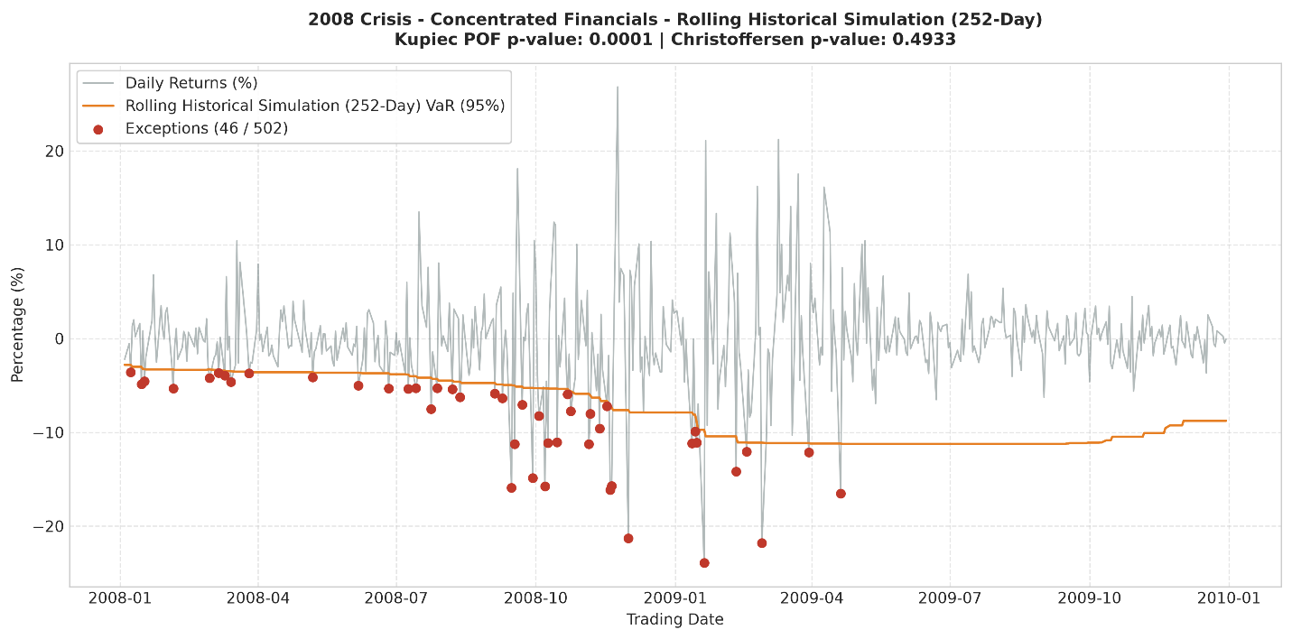
Figure B.1.2: Rolling Parametric Normal Model
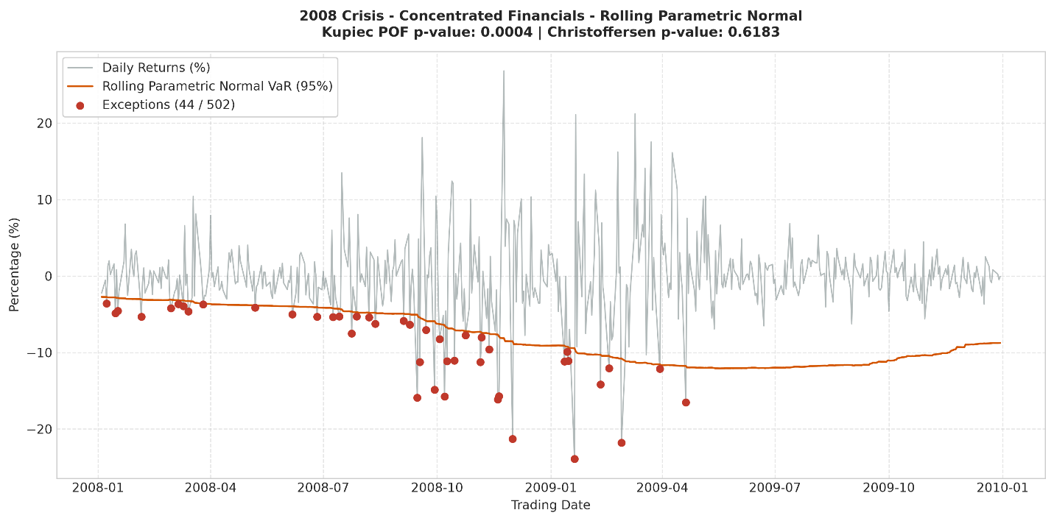
Figure B.1.3: Dynamic Exponentially Weighted Moving Average (EWMA, $λ=0.94$)
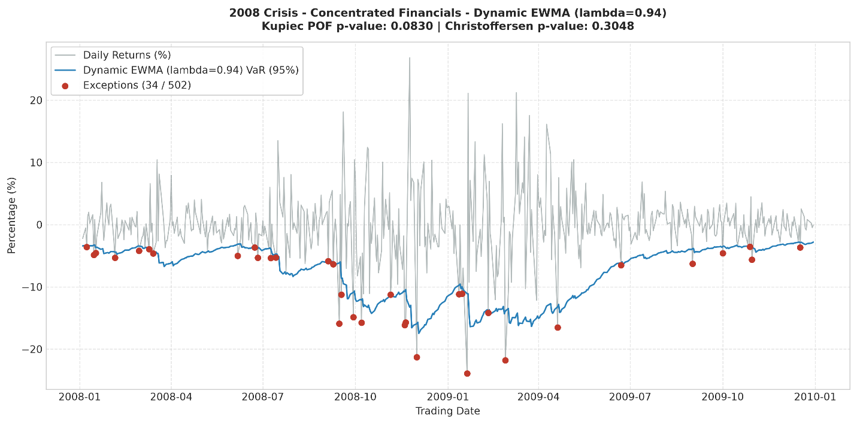
Figure B.1.4: Dynamic GJR-GARCH(1,1) Asymmetric Model 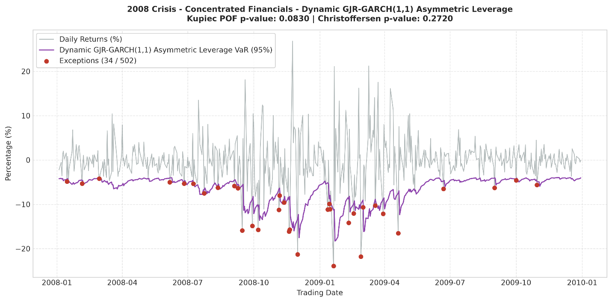 Figure B.1.5: Semi-Parametric Filtered Historical Simulation (FHS)
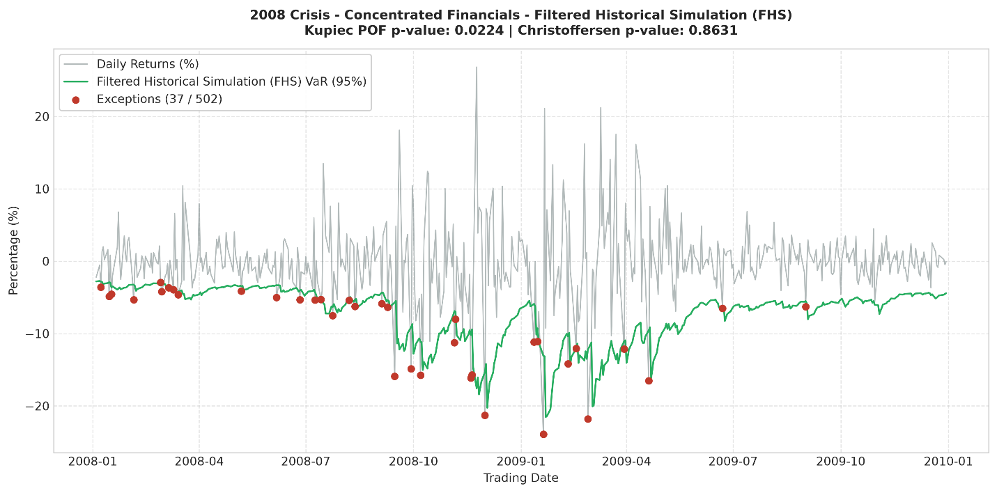
Appendix B.2: Diversified Multi-Asset Portfolio Diagnostics
Figure B.2.1: Rolling Historical Simulation (252-Day Window)
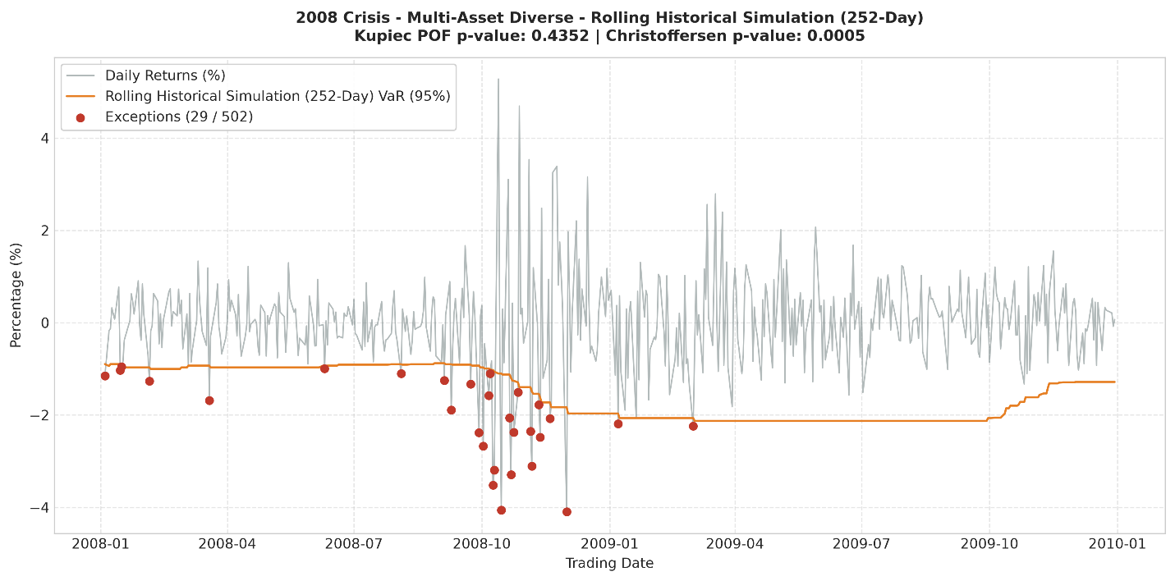
Figure B.2.2: Rolling Parametric Normal Model
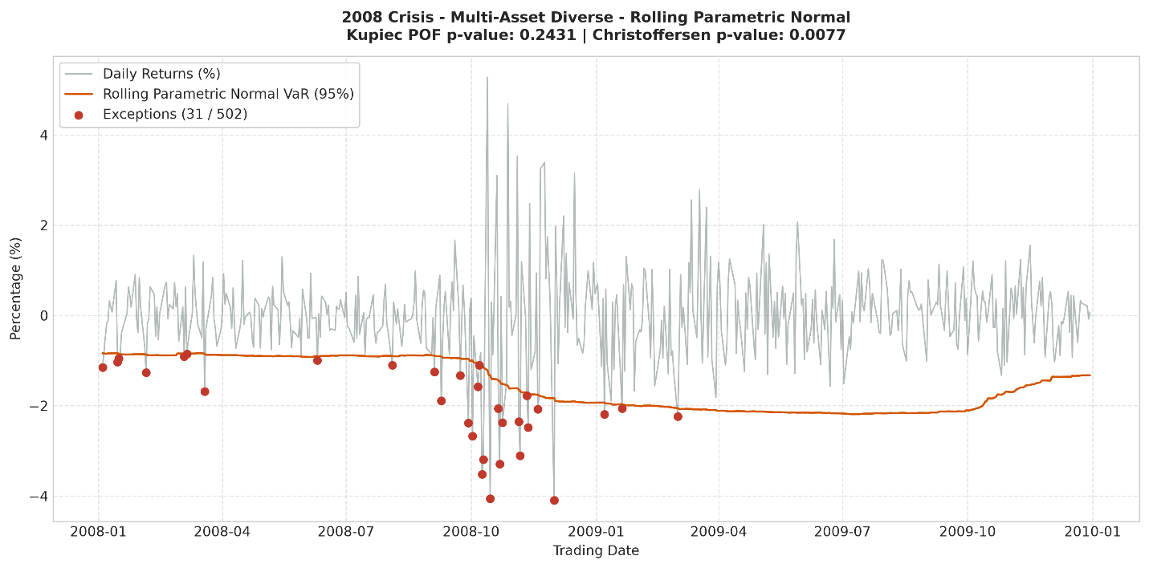
Figure B.2.3: Dynamic Exponentially Weighted Moving Average (EWMA, $λ=0.94$)
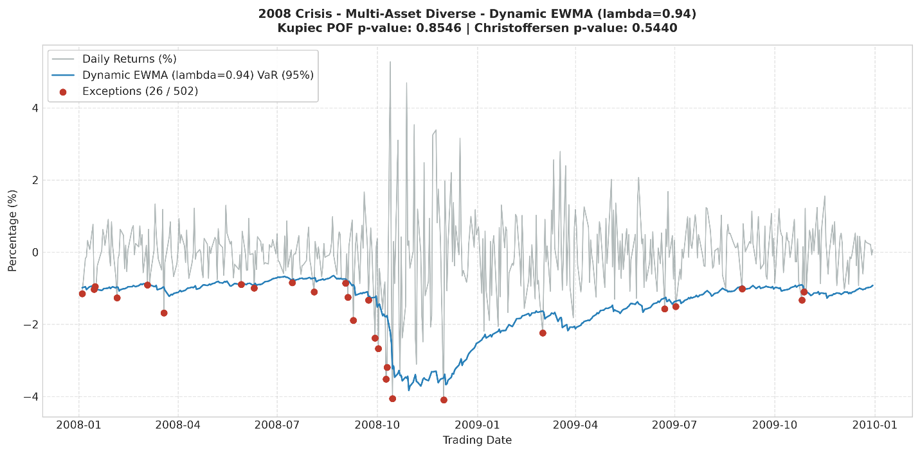
Figure B.2.4: Dynamic GJR-GARCH(1,1) Asymmetric Model
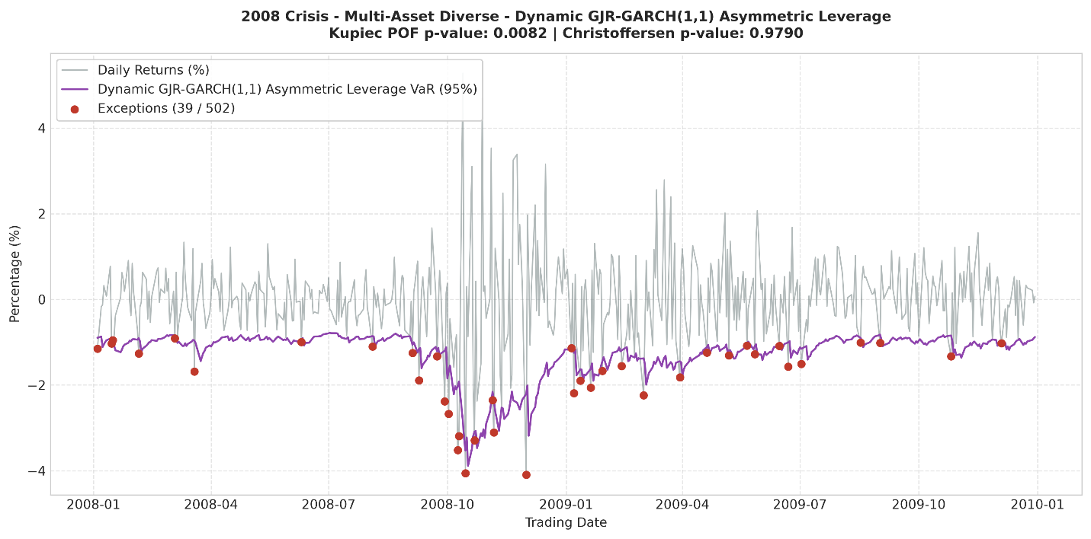
Figure B.2.5: Semi-Parametric Filtered Historical Simulation (FHS)
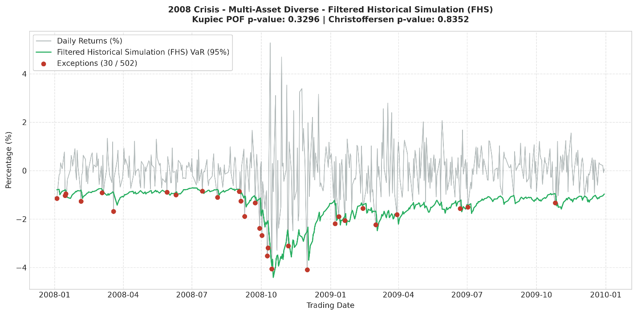

References
Artzner, P., Delbaen, F., Eber, J. M., & Heath, D. (1999). Coherent measures of risk. Mathematical Finance, 9(3), 203–228. https://doi.org/10.1111/1467-9965.00068
Ballabio, L., & Balaraman, G. (2026). QuantLib Python cookbook. Leanpub. https://leanpub.com/quantlibpythoncookbook
Basel Committee on Banking Supervision. (2019). Minimum capital requirements for market risk (Revised market risk framework). Bank for International Settlements. https://www.bis.org/bcbs/publ/d457.htm
Bollerslev, T. (1986). Generalized autoregressive conditional heteroskedasticity. Journal of Econometrics, 31(3), 307–327. https://doi.org/10.1016/0304-4076(86)90063-1
Brandimarte, P. (2006). Numerical methods in finance and economics: A MATLAB-based introduction (2nd ed.). John Wiley & Sons.
Brunnermeier, M. K., & Pedersen, L. H. (2009). Market liquidity and funding liquidity. The review of financial studies, 22(6), 2201-2238. https://www.nber.org/system/files/working_papers/w12939/w12939.pdf
Cont, R. (2001). Empirical properties of asset returns: Stylized facts and statistical issues. Quantitative Finance, 1(2), 223–236. https://doi.org/10.1080/713665670
Crouhy, M., Galai, D., & Mark, R. (2014). The essentials of risk management (2nd ed.). McGraw-Hill Education.
Danielsson, J., & de Vries, C. G. (2000). Value at risk and extreme returns. Annales d'Économie et de Statistique, 60, 239–270. https://doi.org/10.2307/20076258
Duffie, D., & Pan, J. (1997). An overview of value at risk. Journal of derivatives, 4(3), 7-49. https://www.sfu.ca/~poitras/818_r1.pdf
Echaust, K., & Just, M. (2020). Value at Risk estimation using the GARCH-EVT approach with optimal tail selection. Mathematics, 8(1), 114. https://doi.org/10.3390/math8010114
Engle, R. F. (1982). Autoregressive conditional heteroscedasticity with estimates of the variance of United Kingdom inflation. Econometrica, 50(4), 987–1007. https://doi.org/10.2307/1912773
Glosten, L. R., Jagannathan, R., & Runkle, D. E. (1993). On the relation between the expected value and the volatility of the nominal excess return on stocks. The Journal of Finance, 48(5), 1779–1801. https://doi.org/10.1111/j.1540-6261.1993.tb05128.x
Hilpisch, Y. (2018). Python for finance: Master financially-driven data science (2nd ed.). O'Reilly Media.
Hull, J. C. (2023). Risk Management and Financial Institutions (6th Ed.). John Wiley & Sons.
Jorion, P. (2006). Value at risk: The new benchmark for managing financial risk (3rd ed.). McGraw-Hill.
Kahneman, D., & Tversky, A. (1979). Prospect theory: An analysis of decision under risk. In Handbook of the fundamentals of financial decision making: Part I (pp. 99-127). http://ofmind.net/doc/summary/BBS20050420_Kahneman-2003.pdf
Lewinson, E. (2020). Python for finance cookbook: Over 50 recipes for applying modern Python libraries to financial data analysis. Packt Publishing.
Linsmeier, T. J., & Pearson, N. D. (2000). Value at Risk. Financial Analysts Journal, 56(2), 47–67. https://doi.org/10.2469/faj.v56.n2.2343
McNeil, A. J., & Frey, R. (2000). Estimation of tail-related risk measures for heteroscedastic financial time series: An extreme value approach. Journal of Empirical Finance, 7(3–4), 271–300. https://doi.org/10.1016/S0927-5398(00)00012-8
Peng, C., & Simon, C. (2024). Financial modeling with geometric brownian motion. Open Journal of Business and Management, 12(2), 1240-1250. https://www.scirp.net/pdf/ojbm_2024032715190163.pdf

